Best folder structure for your NodeJS, Express, MySQL, MVC with Sequelize ORM projects

Problem with Folder Structures?

Why Folder Structure so important?

ExpressJS
ExpressJS is a node js framework for building web and mobile applications and also managing backend API's. ExpressJS is free and open source framework. Express js provides facilities to build single and multi-page applications as well as hybrid web apps. Using express js we can define routes and serve data accordingly

NodeJS
NodeJS is free and open source javascript runtime environment. The backbon of NodeJS is v8 javascript engine, that's why nodeJS is very performant. NodeJS is Asynchronous, non-blocking, and Event Driven. We can use NodeJS under the MIT license.

MySQL
When you talk about RDMS, first thing that come into your mind is MySQL. MySQL is a relational database management system (RDMS). In MySQL we store data in tables, row and columns form. MySQL is the most popular open-source database system in the world. MySQL is very compatible with all programming languages.

MVC
I am using Model View Controller architecture in this toturial. When we follow The Model-View-Controller (MVC) architectural pattern we divide our applications into three main parts. The backend that contains all the data logic called models. The graphical user interface (GUI) or frontend pages are called view. Controllers controls how data is displayed in our application.

Sequelize
I am using Sequelize Object-Relational Mapping (ORM) in this tutorial.

errors
helpers
lib-files
Controllers in Express
cronJobs
Models, Migrations and Seeders
Middle-wares in Express
Routes in express
services in express
validators
.env + app configurations
docker files
node_modules
app scripts
static files
swagger api docs

Conclusions

GitHub links

Very first folder is an app folder that contains our complete project files, In app folder
Controllers
routes
services
validators
middleware
lib
Cron-Jobs
Data
errors
helpers

Let’s discuss these main folders and their sub-folders structure.

Controllers
Your app controllers contains the main business logic of your application. First of create different folders of each type application users e.g in this tutorial we have two types of users (Admin and end-user).
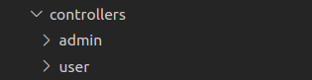

For better understanding and easiness create separate folder for each your application module. For example we have different modules for admin and end-users.
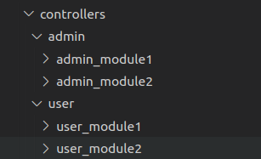

Now we have separate folder for each module, every module maybe contains one or more than one files for module business logic. For example:
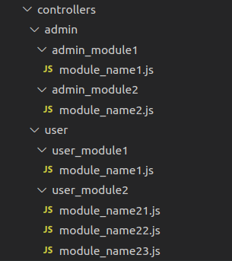

This is the best practice and folder structure for your application controllers. You can easily scale your application controllers. It is easy to understand for developers. Developers can easily work with suggested folder structure for application controllers.

Routes
Routes are the main entry points of your application. Write your all routes related logic inside of routes folder.

Create a separate folder for each type of application users, similar we have discussed for controllers. Then divide application routes into separate module. Each module contains it’s own routes file. And finally require your modules routes inside of the root index file. Example

Routes Folder structure:

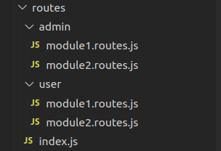

Definition of routes inside of module file:

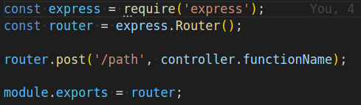

Routes Index.js file, require all your routes inside of index.js root file

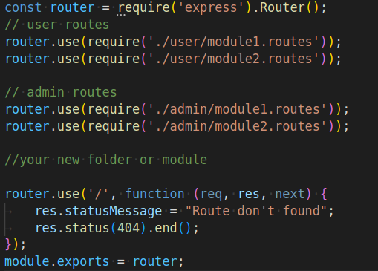

Services
In Model View Controller (MCV) service is an extra security layers between your controllers and models. It is good practice to use separate services for each module. As a developer when we work on an existed system sometimes we need to understand the system architecture as soon as possible.

Services folder structure:

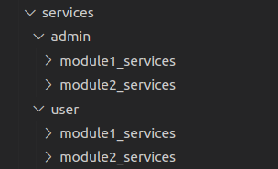

Middleware
Middle-wares are basically functions that will have all the access for requesting an object. You can use middleware for different purposes token verification, permissions check, user validation and verification etc. Put your all middleware inside of a separate folder in app directory.

Validatiors

3] Models:- All the database models should go into the models folder. Again you should write each model into its own file. e.g. User model in UserModel.js.
4] Public:- All the public files such as images, javascript files, CSS files should go into this folder. You should divide your files into their own folder.
5] Routes:- All your routing-related logic should go into this folder. Again divide this logic into multiple files based on functionality. i.e User routing functionality should go into UserRouter.js.
6] Views:- So this folder contains all your views i.e. HTML/ejs files. Drop this folder if you are building rest API’s.
7] config.js:- This file should contain all your configuration e.g. PORT number, secrets, keys etc. Do not commit this file to Git.

